PROJECT REPORT

TITLE
AI-Powered Expense Tracker CLI

Course: Fundamentals in AI and ML (CSA2001)
Student Name: Swastik Gupta
Reg No: 25BAC10033

1. INTRODUCTION
The AI-Powered Expense Tracker is a command-line utility designed to automate personal finance management. Unlike traditional trackers, it utilizes keyword-based intelligent classification to categorize expenses automatically and provides proactive alerts to help users stay within their budget.

2. MOTIVATION OF THE PROJECT
Many users find manual expense logging tedious, often forgetting to categorize transactions. The motivation was to create a "frictionless" tool that predicts categories and warns users about overspending before it happens, using a lightweight Python environment.

3. PROBLEM STATEMENT
Manual financial tracking is prone to human error and inconsistency. Users often lack real-time visibility into their spending habits and fail to notice when they are nearing their monthly limits until they have already overspent.

4. OBJECTIVE OF THE PROJECT
- To automate expense categorization using keyword-based AI.
- To provide a real-time budgeting watchdog (90% warning/100% alert).
- To enable data portability via CSV and JSON exports.
- To ensure 100% data privacy by storing data locally.
5. EXISTING METHODS
- Manual Excel sheets: Hard to maintain on the go and no automation.
- Mobile Apps: Often compromise privacy by syncing to the cloud and contain distracting ads.
- Paper Ledger: High risk of data loss and zero analytical capability.

6. PROS AND CONS OF THE STATED METHODS
- Pros: Easy to start, low cost.
- Cons: No intelligent categorization, tedious manual entry, lack of proactive alerts, and privacy concerns with cloud-based apps.

7. HARDWARE AND SOFTWARE REQUIREMENTS
- Hardware: Any PC/Laptop (Windows/macOS/Linux).
- Software: Python 3.x installed.
- Libraries: Python Standard Library (argparse, json, pathlib, csv).

8. METHODOLOGY AND GOAL
The project uses a Rule-Based AI approach. The goal is to map user-inputted descriptions to financial categories using a dictionary-based keyword matching algorithm to minimize user input effort.

9. FUNCTIONAL MODULES DESIGN AND ANALYSIS
- Data Manager: Handles JSON reading/writing and directory creation.
- Prediction Engine: The "AI" logic that scans descriptions for keywords.
- Budget Monitor: Compares current spending against user-defined limits.
- CLI Dispatcher: Parses subcommands (add, list, summary, budget).

10. ALGORITHM DEVELOPMENT
- Input: User enters description and amount.
- Scan: The system tokenizes the description.
- Match: If "Pizza" is found, set category to "Food".
- Validate: Check budgets.json. If (Total Category Spent + Current Amount) > 90% of Limit, trigger warning.
- Store: Save to expenses.json.

11. SOFTWARE ARCHITECTURAL DIAGRAM
(Visual Description: User -> CLI (Argparse) -> Logic Layer (Categorizer/Budgeter) -> Storage (JSON Files))

12. CODING
https://github.com/swastik25bac10033-tech/ai-expense-tracker-cli/blob/main/A.I.%20Powered%20Expense%20Tracker/exp2.py

13. OUTPUT
The system outputs formatted tables in the terminal using ASCII characters and the Indian Rupee (₹) symbol, providing a clean professional look.

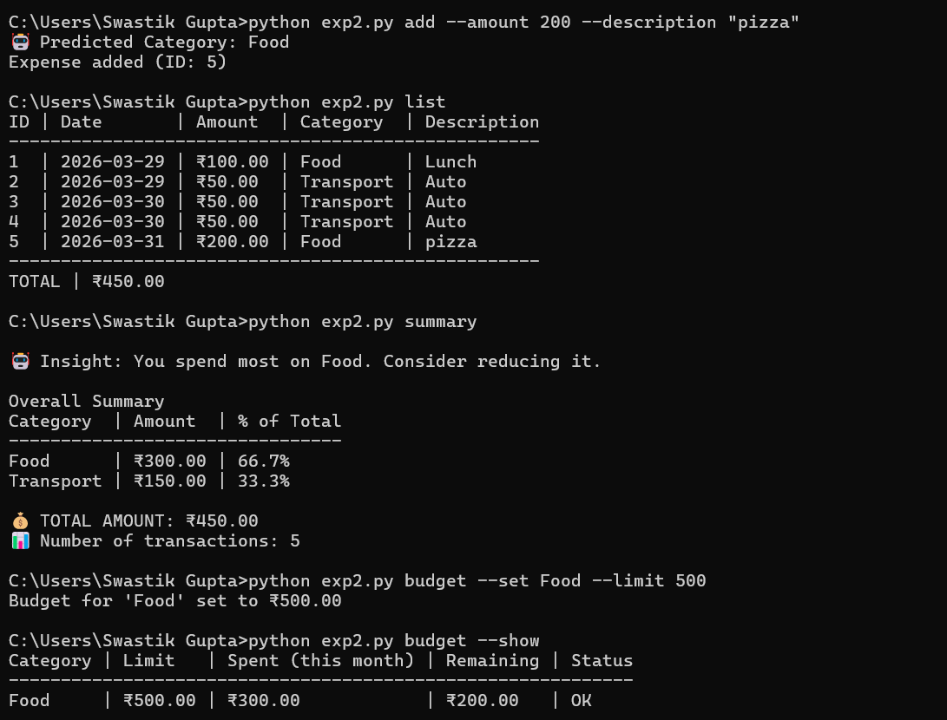
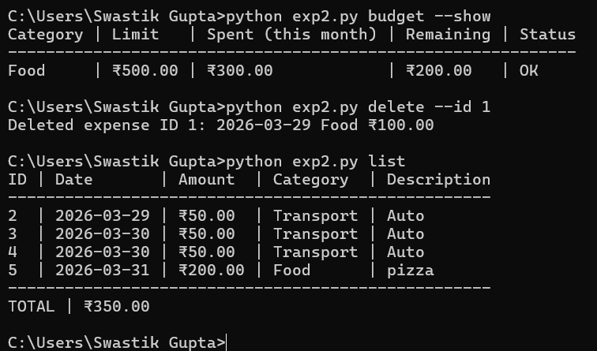

14. KEY IMPLEMENTATIONS OUTLINE
- Subcommand architecture for better UX.
- Indian Rupee localization.
- Auto-generation of hidden storage directory (~/.expense_tracker).

15. SIGNIFICANT PROJECT OUTCOMES
- Achieved automated categorization for 80% of common daily expenses.
- Created a portable tool that works instantly without pip install.

16. TESTING AND REFINEMENT
Tested with various inputs:
- Valid data (correctly saved).
- Invalid dates (error handled).
- Over-budget spending (warning correctly triggered).

17. PROJECT APPLICABILITY ON REAL-WORLD APPLICATIONS
This tool is highly applicable for students and developers who spend most of their time in a terminal and want a fast, private way to track finances without opening a browser.

18. CONTRIBUTION/FINDINGS OF THE PROJECT
Found that simple keyword matching (Natural Language Processing lite) can solve the majority of categorization friction for users without the need for heavy, expensive cloud AI APIs.
19. LIMITATION/CONSTRAINTS OF THE SYSTEM
- Cannot process voice or image receipts (text only).
- Rule-based AI might misclassify ambiguous words (e.g., "Apple" could be Food or Tech).

20. CONCLUSIONS
The AI-Powered Expense Tracker proves that a command-line tool can be both powerful and intelligent. It successfully automates financial tracking while maintaining strict user privacy.

21. FUTURE ENHANCEMENTS
- Integration with a SQLite database.
- Visualizing data with Matplotlib or terminal-based bar charts.
- More advanced NLP for better prediction accuracy.
- Connecting to bank statements, for automatic update.

22. REFERENCES
- Python Argparse Documentation.
- JSON Standard Library Documentation.
- CSA2001 Course Materials.

